**Steps to generate REMC report using the script**

**Open the folder of the script**

**Collect the input data excel files**

* Paste the SCADA files in the volt, tot_gen, ists_gen folders. If report is for 15-Jul-2020, the filenames should be 2020716.xlsx
* Download the REMC zip files of all forecast providers (FCA, IFT, Aleasoft, Enercast, RES) from REMC portal
* Paste the appropriate files in the folders fca, ift, aleasoft, enercast, res.   
  A sample list of filenames requiresd for creating the reports **for 15-Jul-2020** are
  + **fca/DAY_AHED_2020-07-16.csv**
  + **fca/FC_VS_AC_2020-07-16.csv**
  + **fca/FC_VS_AC_2020-07-15.csv**
  + **ift/FC_VS_AC_2020-07-16.csv**
  + **aleasoft/FC_VS_AC_2020-07-16.csv**
  + **enercast/FC_VS_AC_2020-07-16.csv**
  + **res/FC_VS_AC_2020-07-16.csv**

**Run the script**

* double click the run.bat
* Open the report_template.xlsx file and save it in order to trigger evaluation of formulas
* Save as in a separate folder with name like 'REMC_Report_2020_07_15.xlsx'
* Ctrl + select all sheets execpt 'remc_graph_data', 'scada_graph_data' sheets and print the excel as pdf
* Make sure all the files and folders are closed after successful report generation

**Snapshots for reference**

**REMC portal for data zip files download**

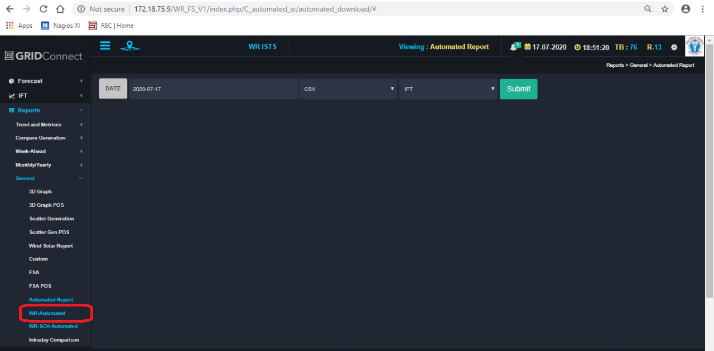

**Folder of the script**

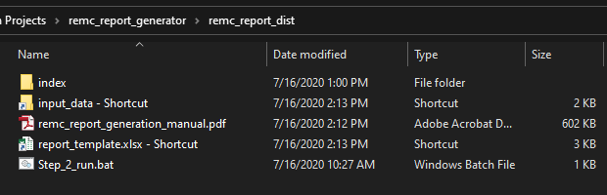

**Input_data folder**

